

GROUP ASSIGNMENT

**LEVEL 4**

**COMP40004:**   
WEB DEVELOPMENT AND OPERATING SYSTEMSII

Hand Out Date:

Hand In Date: 9th August 2024

**INSTRUCTION TO CANDIDATES**

1. **Students are advised to comply referencing with Harvard Referencing Style. Preferably, use Mendeley or EndNote.**
2. **Late submission will be awarded zero (0) unless extenuating circumstances (EC) are upheld.**
3. **Cases of plagiarism will be penalized.**
4. **The assignment should be submitted as softcopy via LMS**

## Introduction

This report Is mainly focused on designing the functionality of the website which was specifically designed for a client named “Grocies Supermarket “To complete this project we primarily used Java script to improve the functionality of this website and then this report will mostly talk about the testing of this website based on different aspects like Functionality testing, Accessibility testing using wave, HTML validation, CSS validation and Lighthouse testing.

For these above-mentioned testing was done using tools which were free on the internet

* HTML validation: <https://validator.w3.org/>
* CSS validations: <https://css-validator.org/>
* Accessibility testing: <https://wave.webaim.org/>
* Lighthouse testing : tool in the chrome Brower
* Functionality testing : this test was done using the excel sheet with the test cases

## HTML Validations

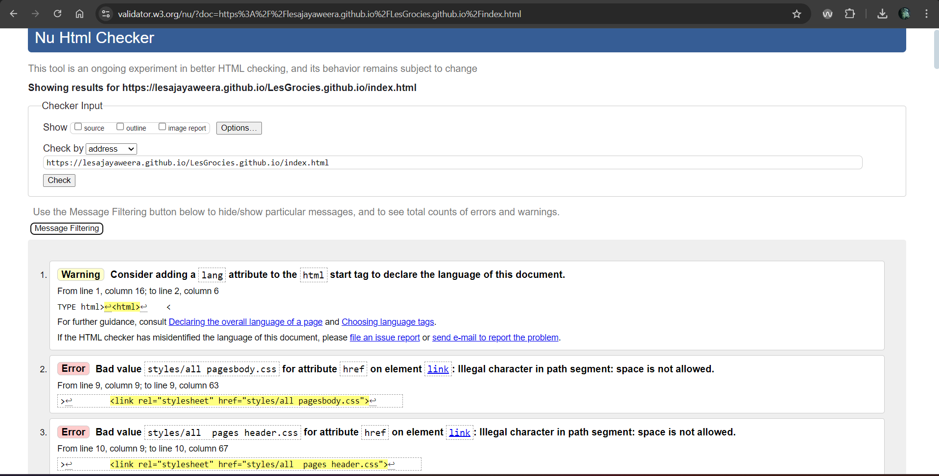

Figure 1: home page HTML validations

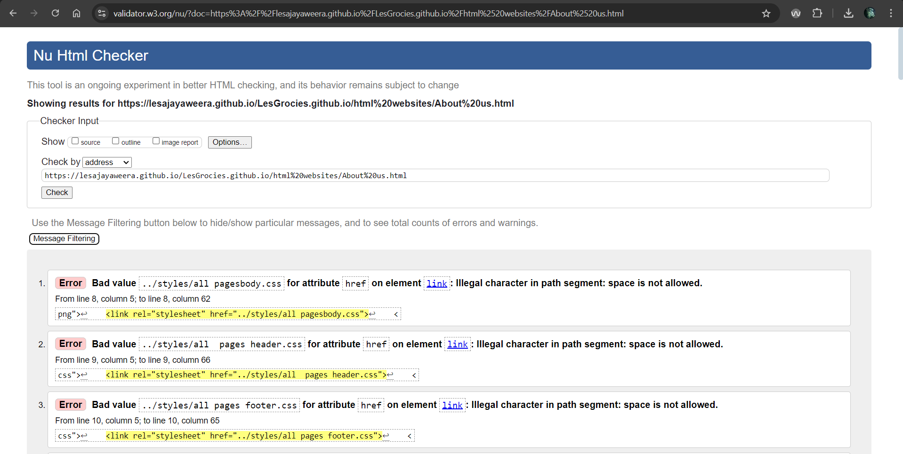

Figure 2 About us page HTML validations

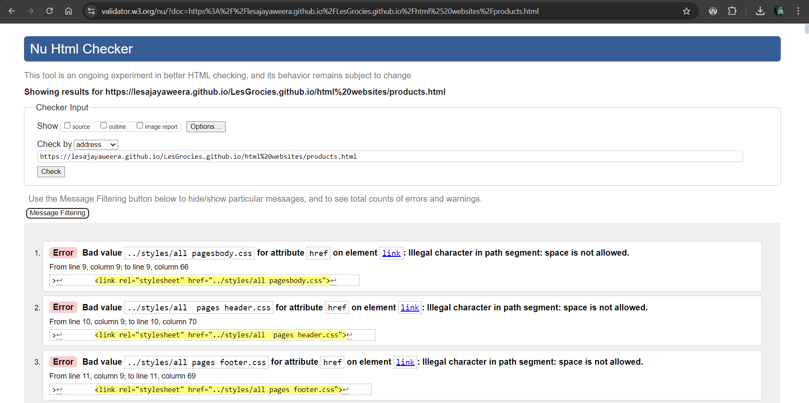

Figure 3 Products page HTML validations

Figure 4 Vegetable HTML validations

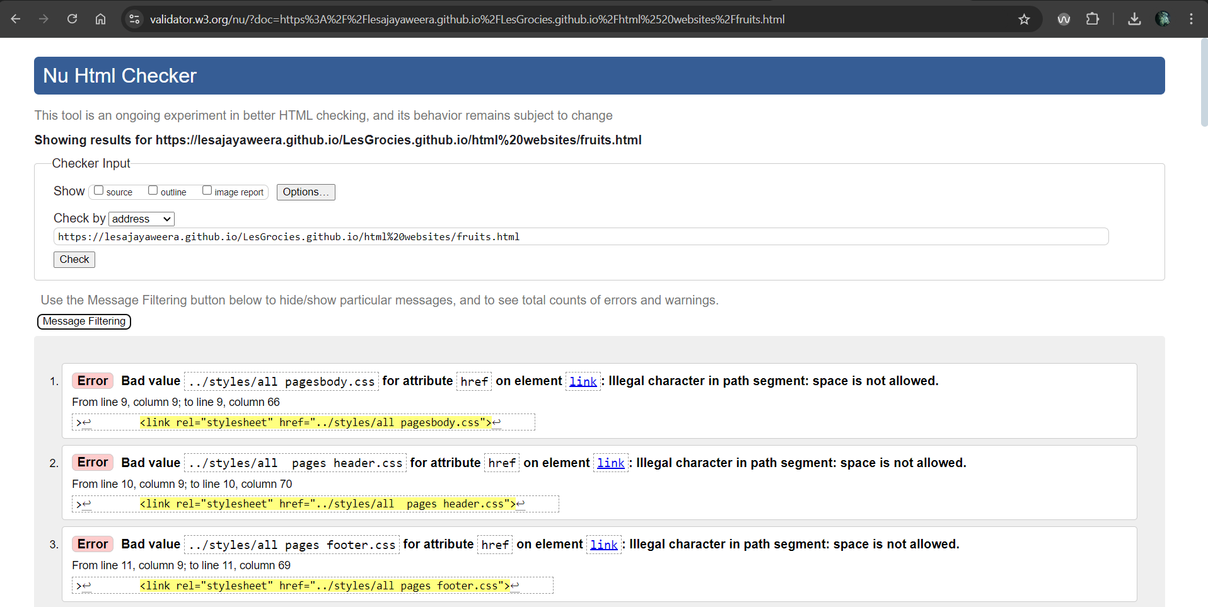

Figure 5 Fruits HTML validations

Figure 6 Dairy HTML validations

Figure 7 Cosmetic HTML validations

Figure 8 Fish HTML validations

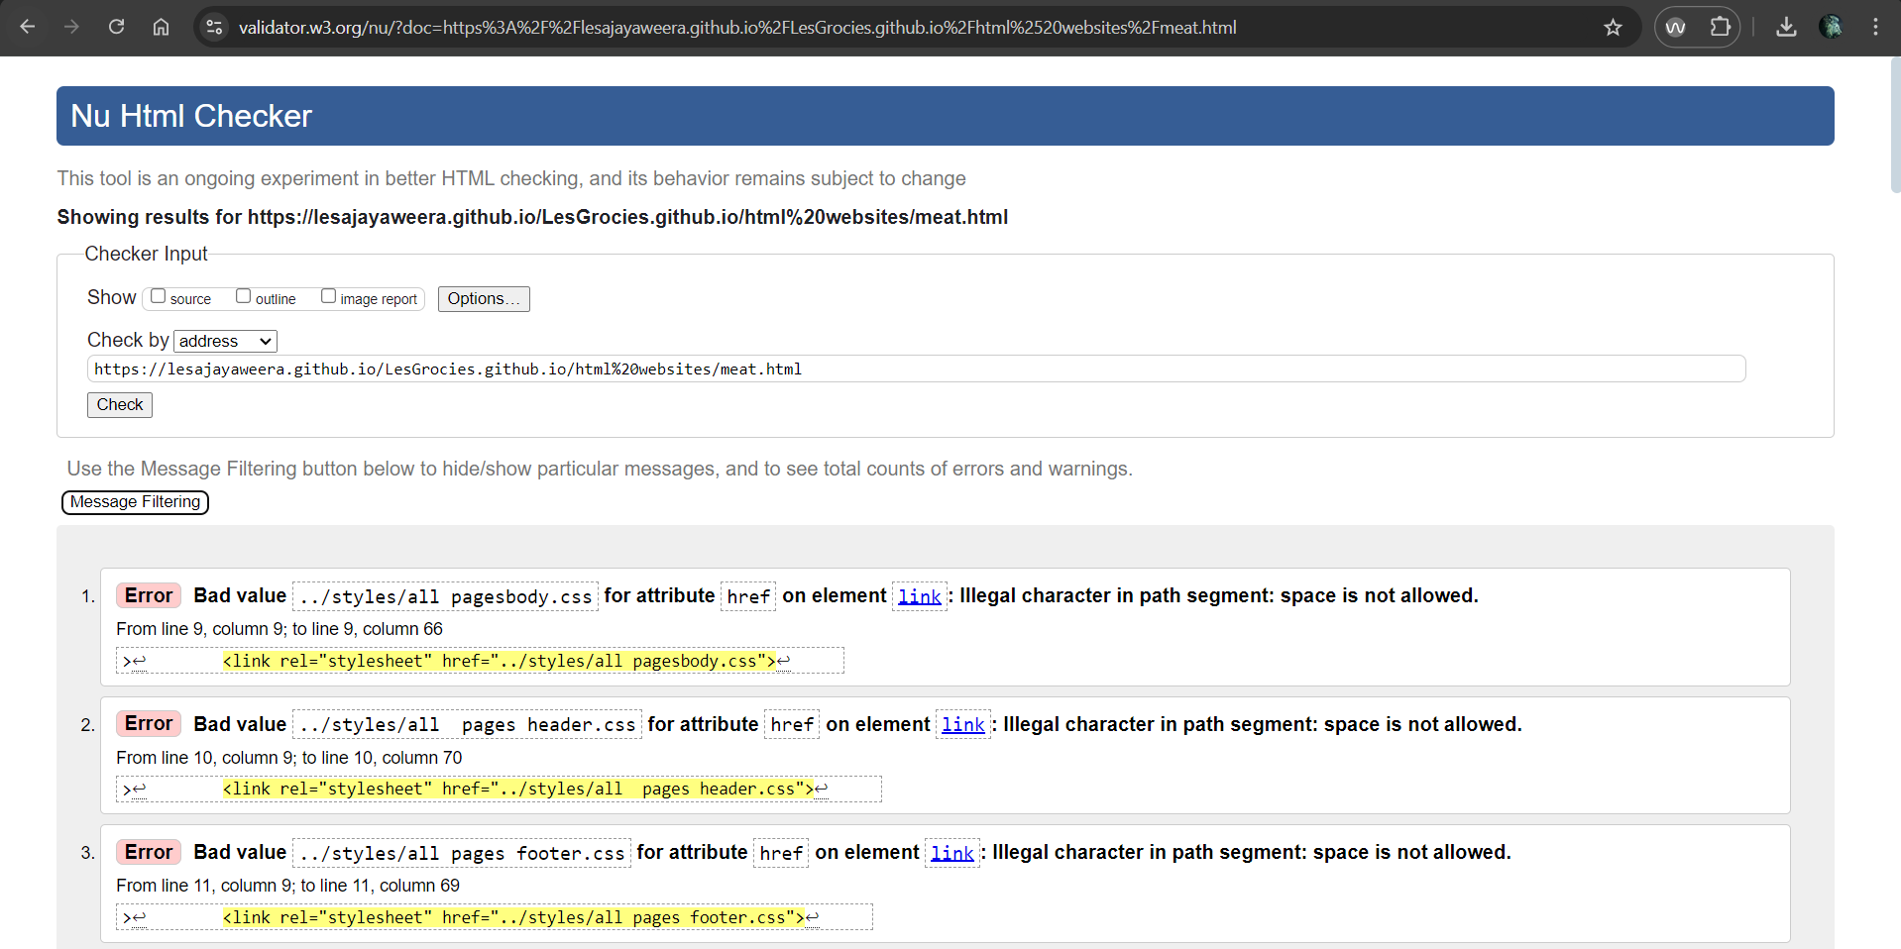

Figure 9 Meat HTML validations

Figure 10 Baking and cooking HTML validations

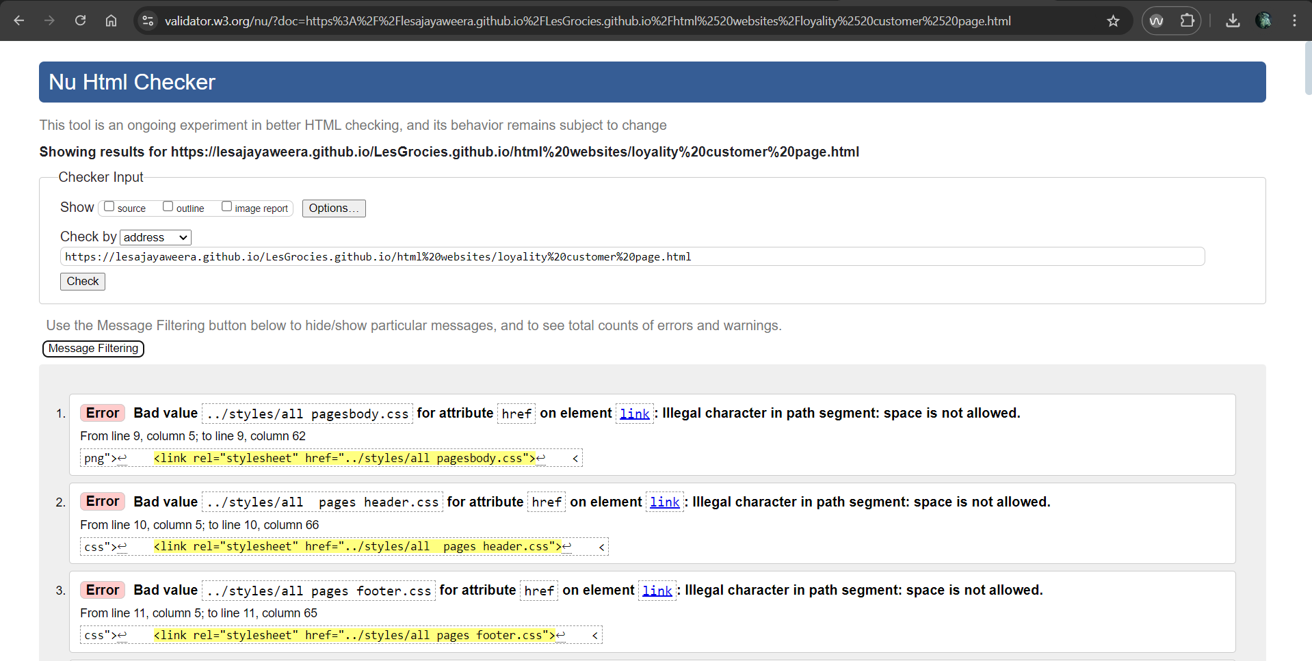

Figure 11 Loyalty HTML validations

Figure 12 Order HTML validations

Figure 13 Checkout HTML validations

## CSS Validations

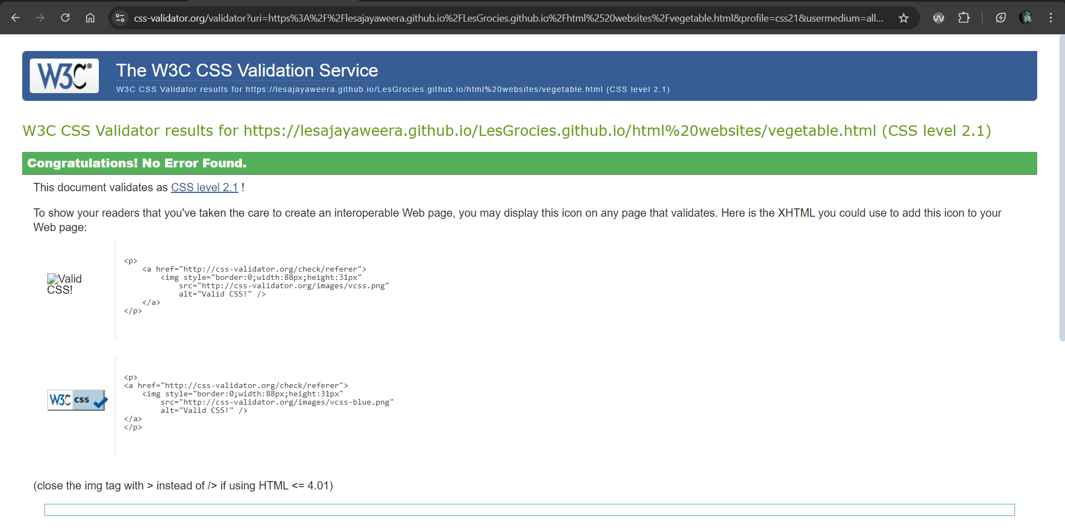

Figure 5 veegtables css validation

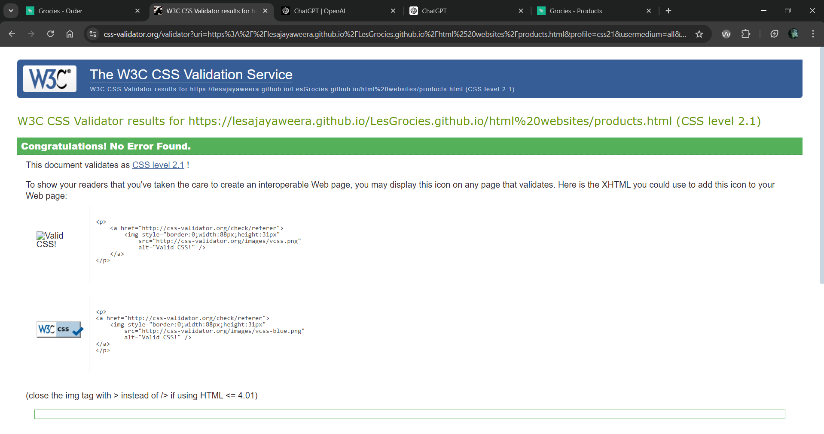

Figure 6 products css validations

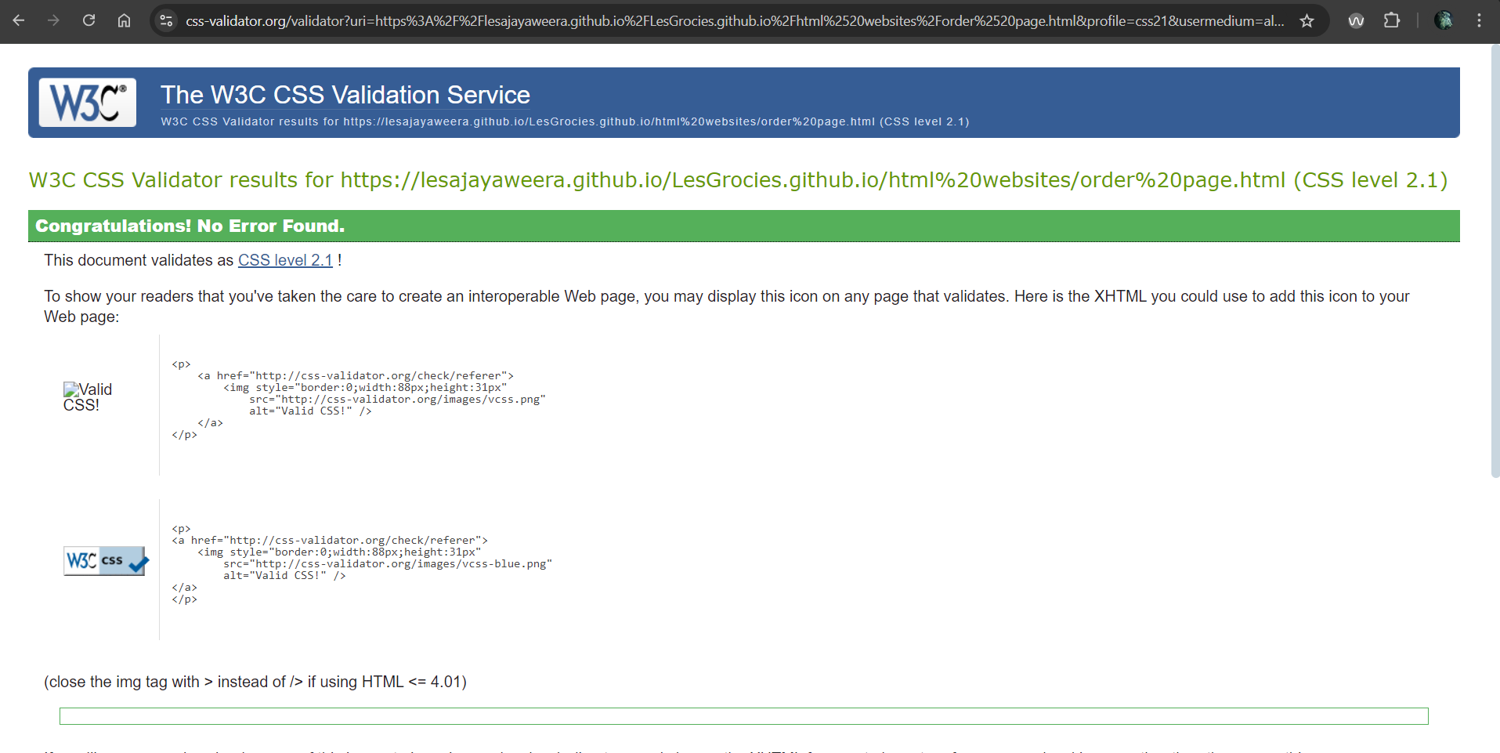

Figure 7 order Css validations

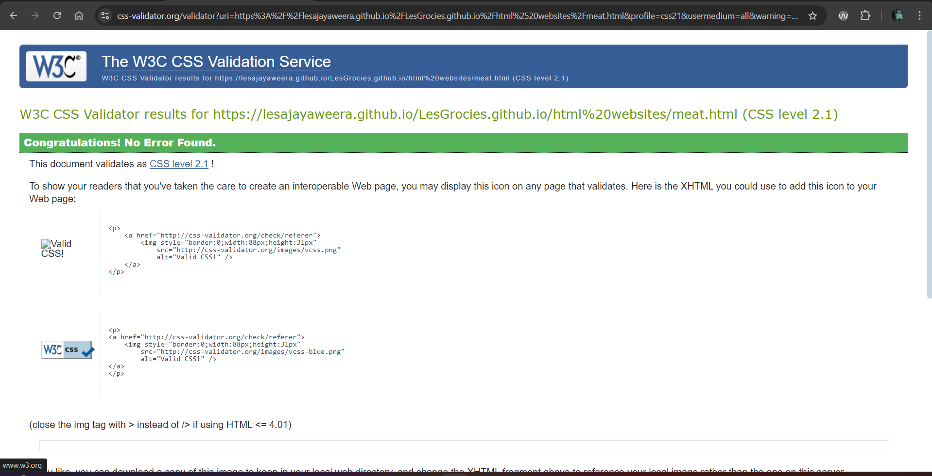

Figure 8 meat css validations

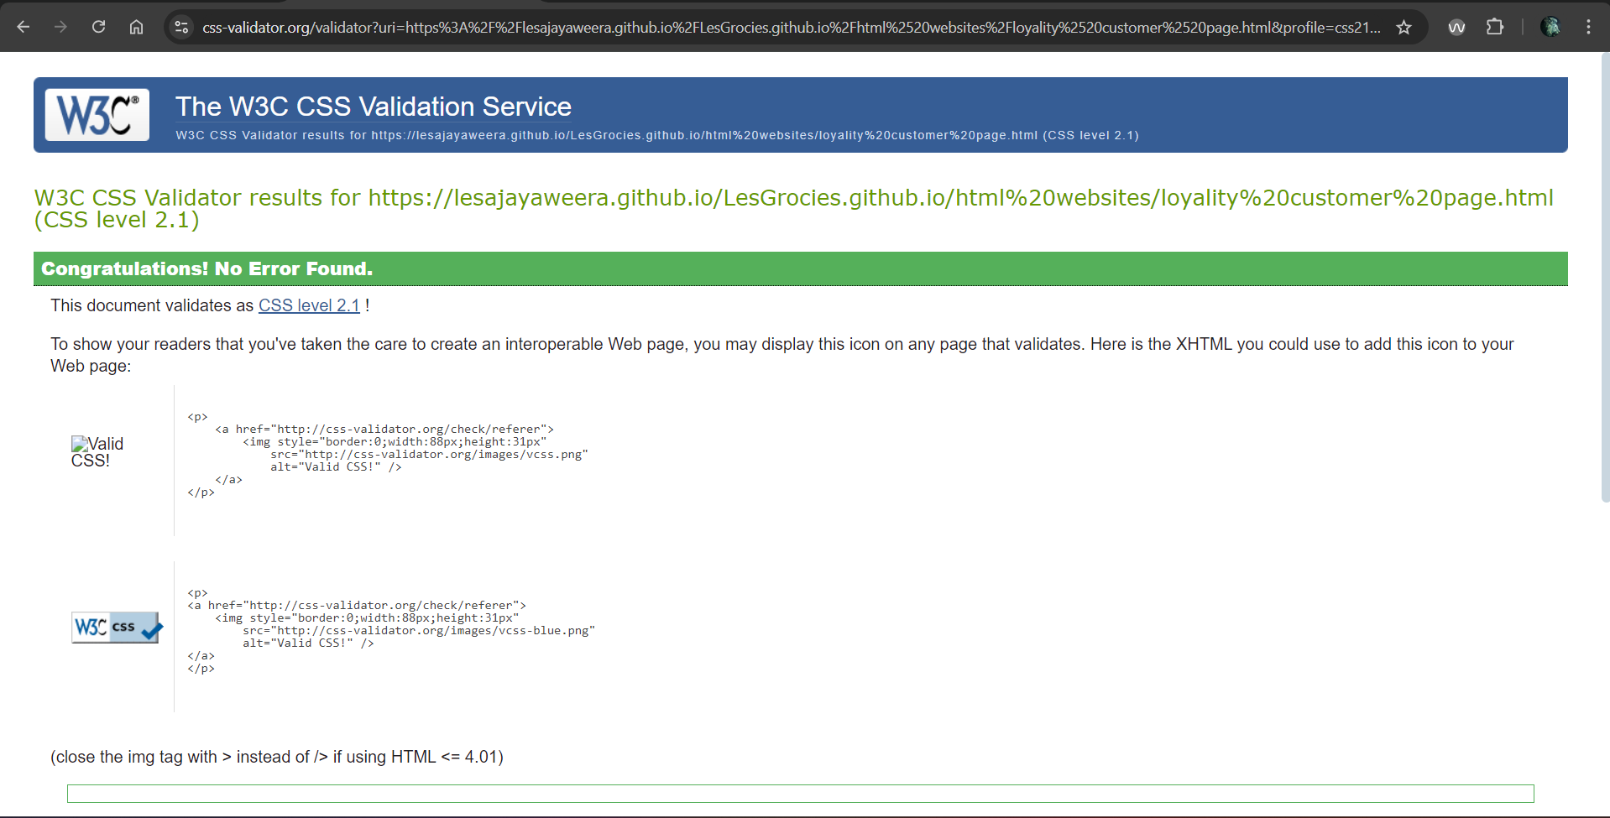

Figure 9 loyalty customer css validations

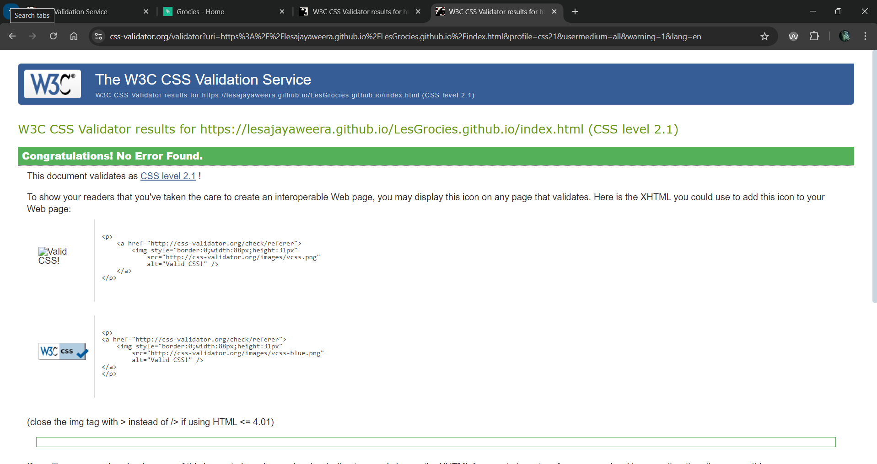

Figure 10 home css validations

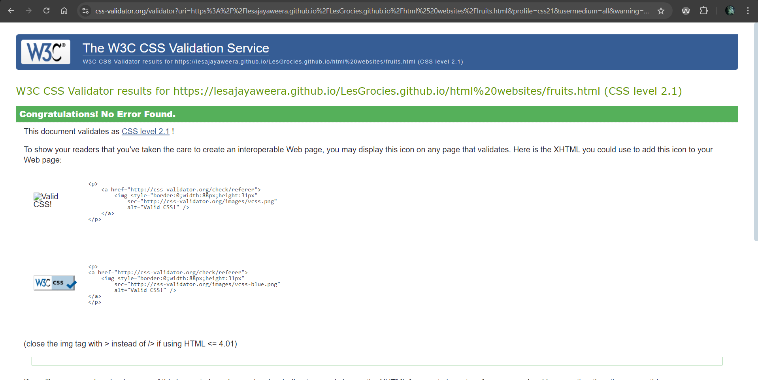

Figure 11 fruits css validations

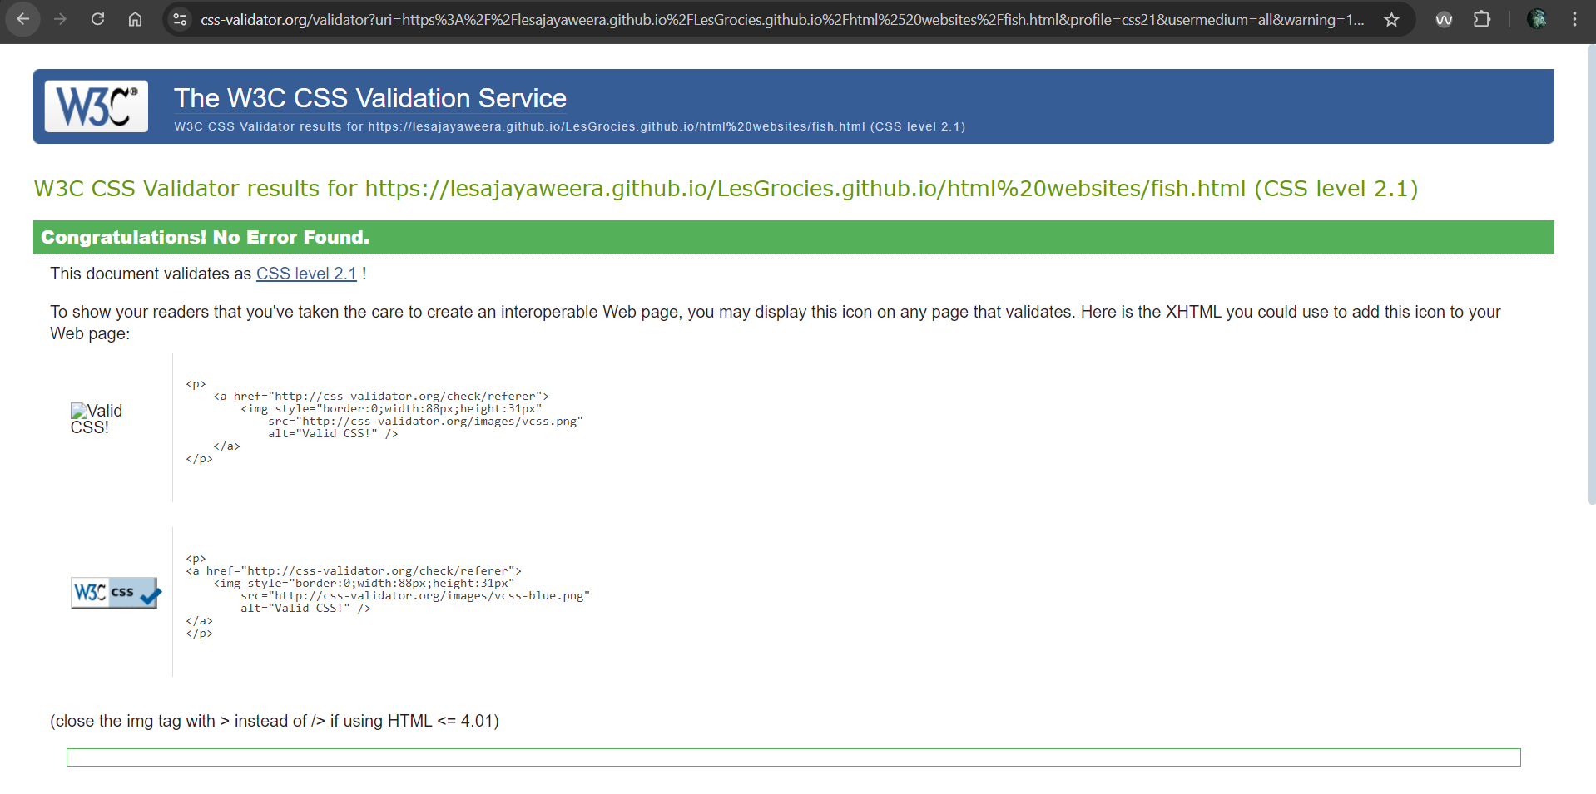

Figure 12 fish css validations

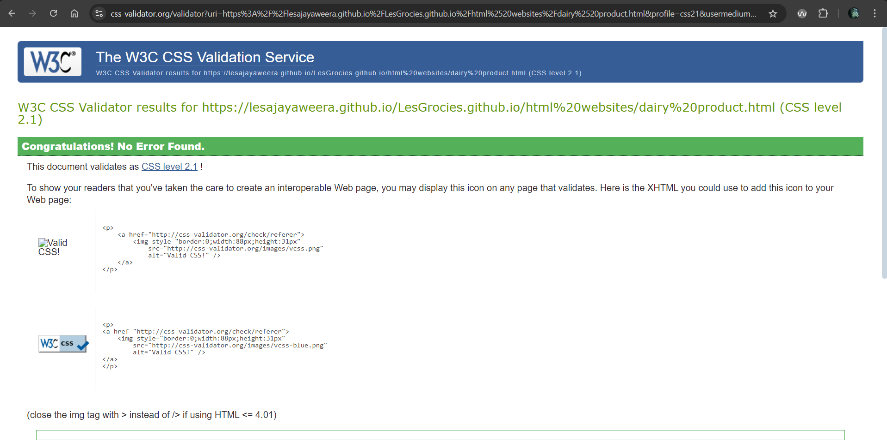

Figure 13 dairy products css validations

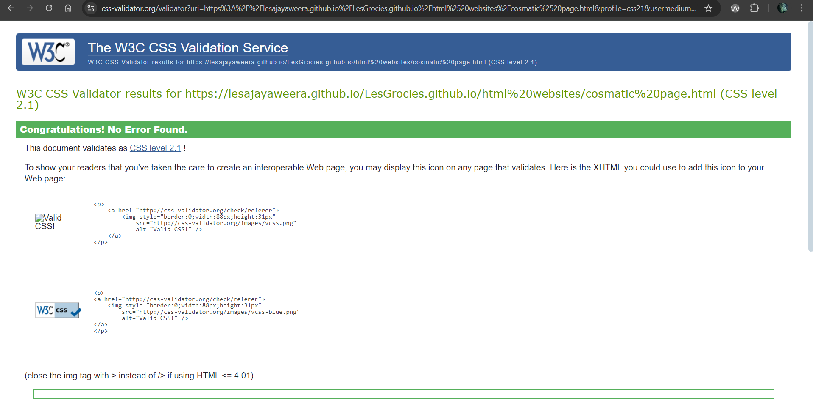

Figure 14 cosmatic css validations

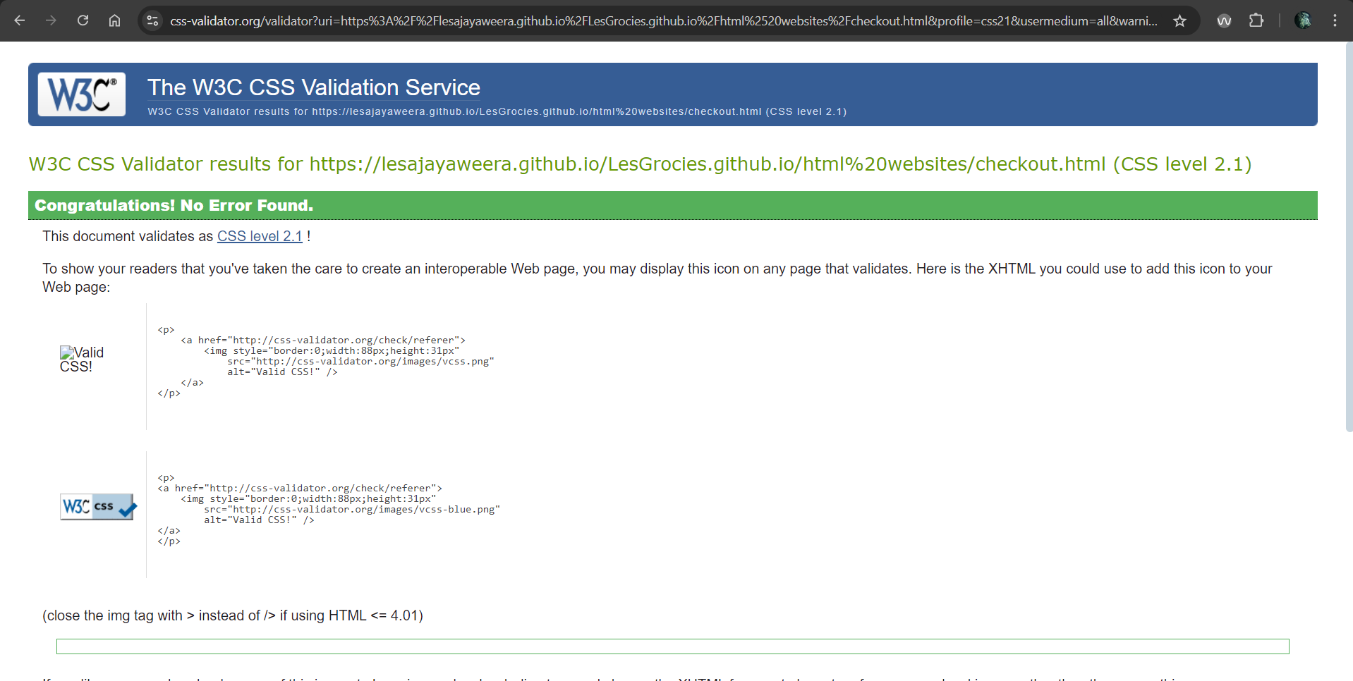

Figure 15 checkout css validations

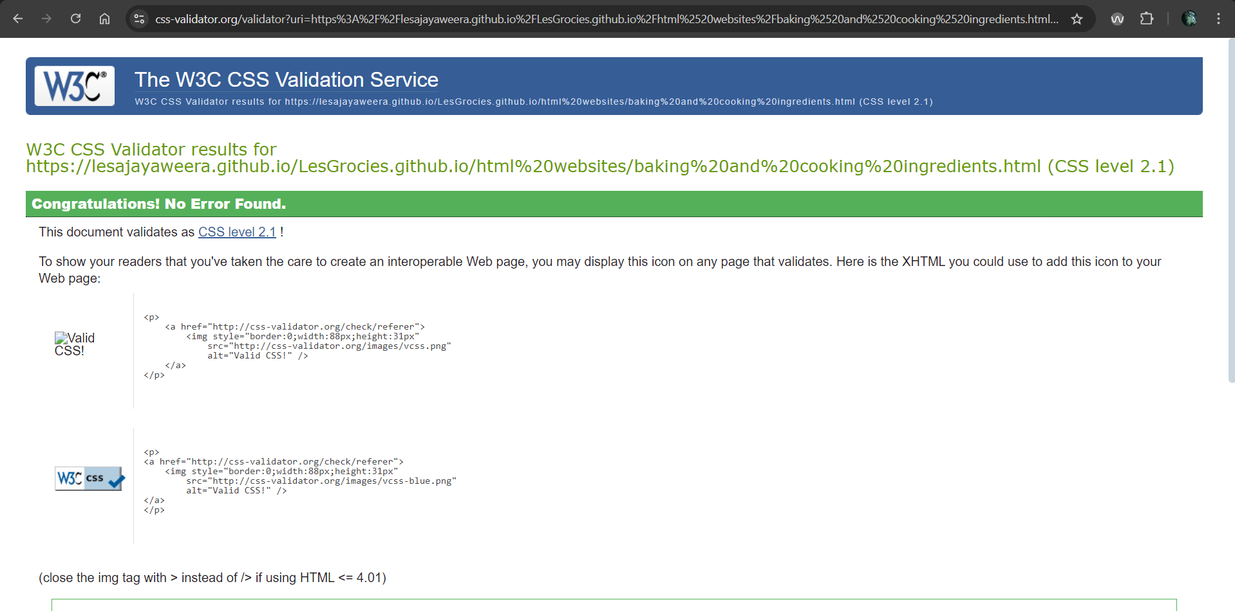

Figure 16 cooking and bakery ingrediants

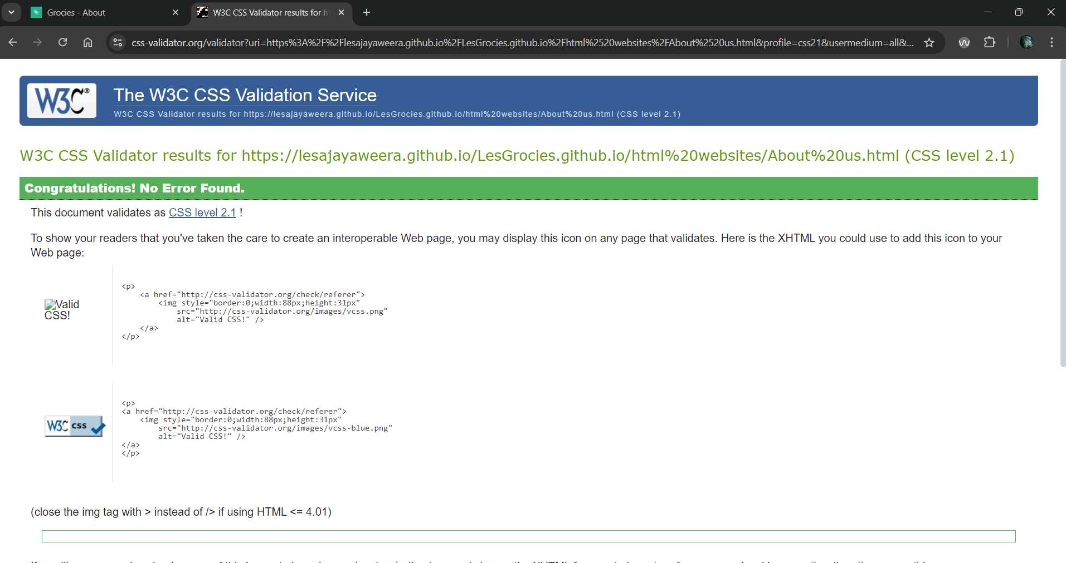

Figure 17 about us css validations

## LightHouse testing

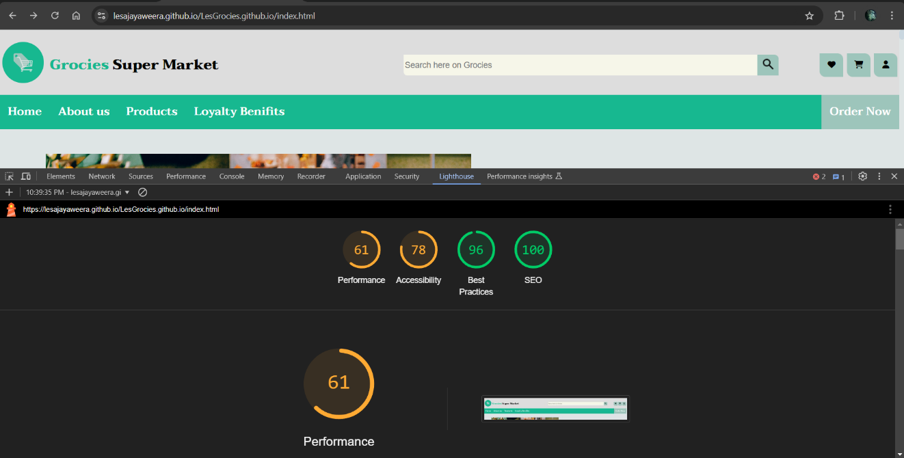

Figure 18 home desktop light house

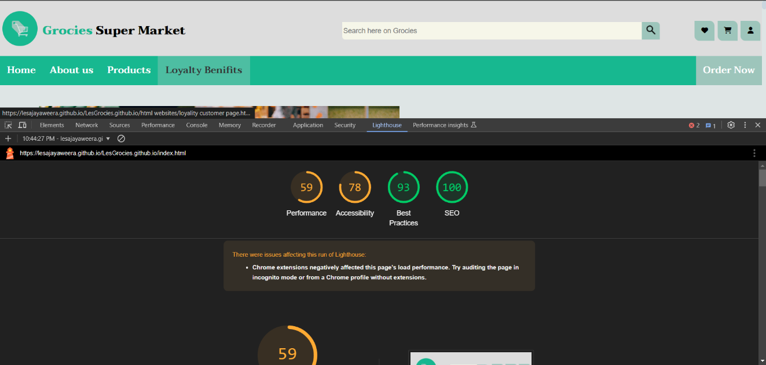

Figure 19 home mobile lighthouse

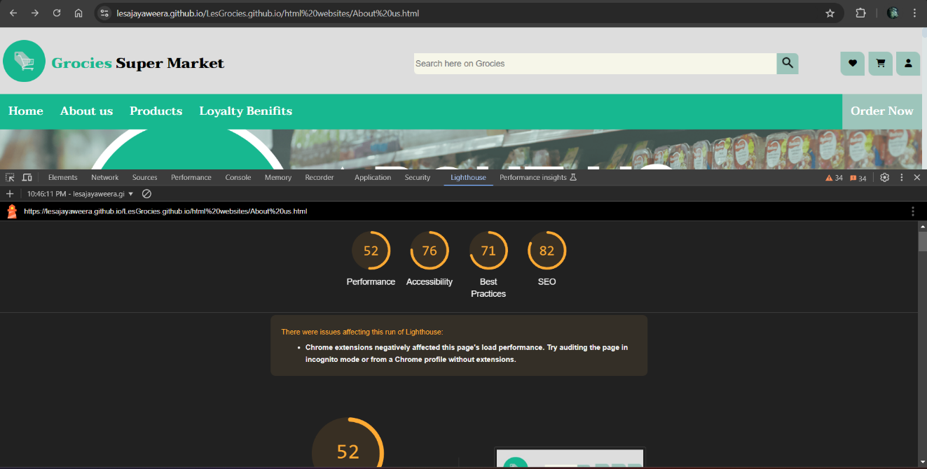

Figure 20 aboust us desktop lighthouse

Figure 21 about us mobile light house

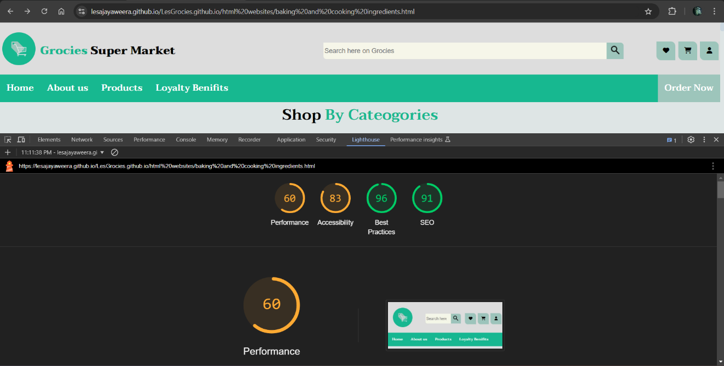

Figure 22 baking and cooking desktop light house

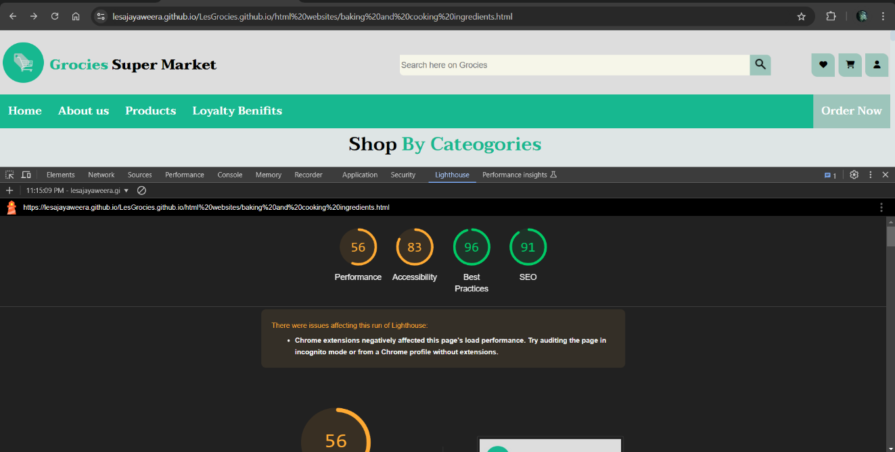

Figure 23 baking and cooking mobile lighthouse

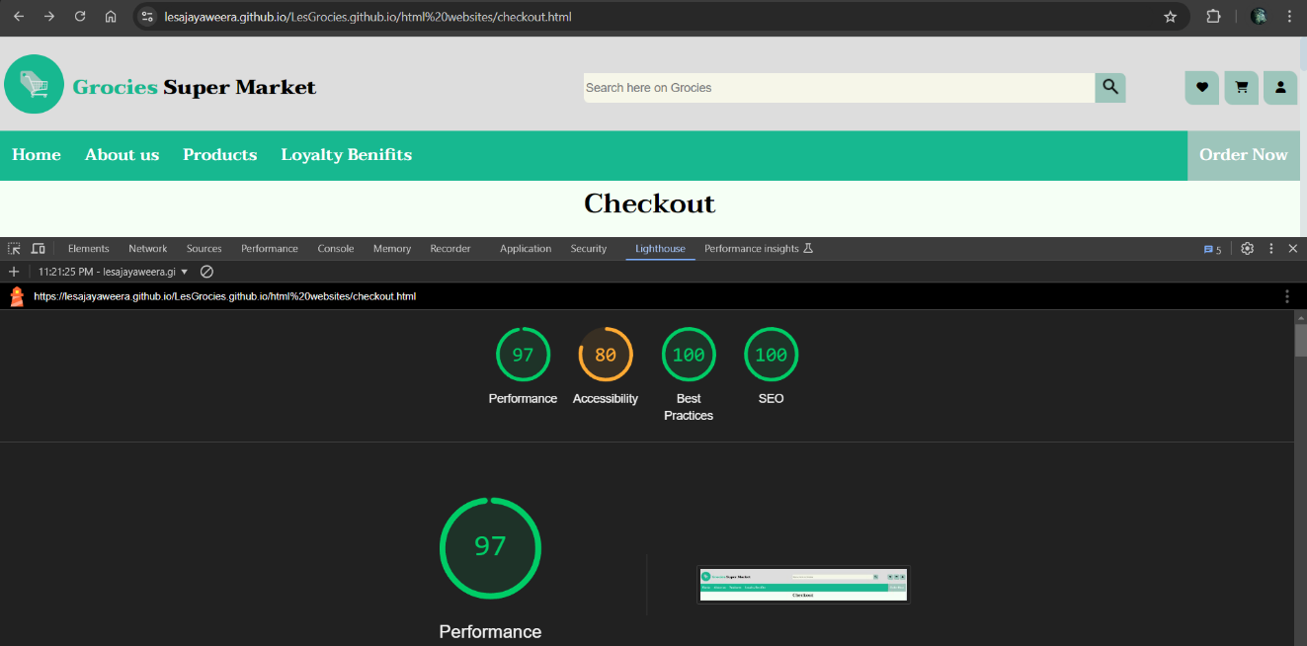

Figure 24 checkout desktop lighthouse

Figure 25 cosmetic desktop light house

Figure 26 checkout mobile lighthouse

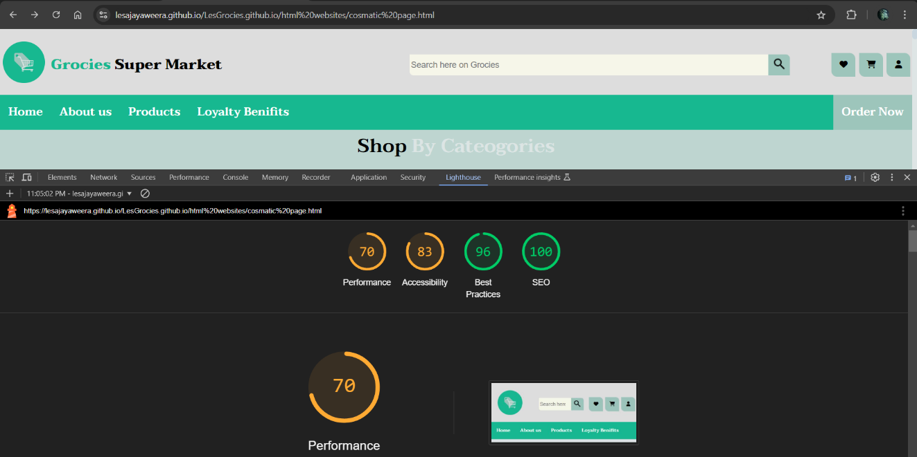

Figure 27 cosmetic mobile light house

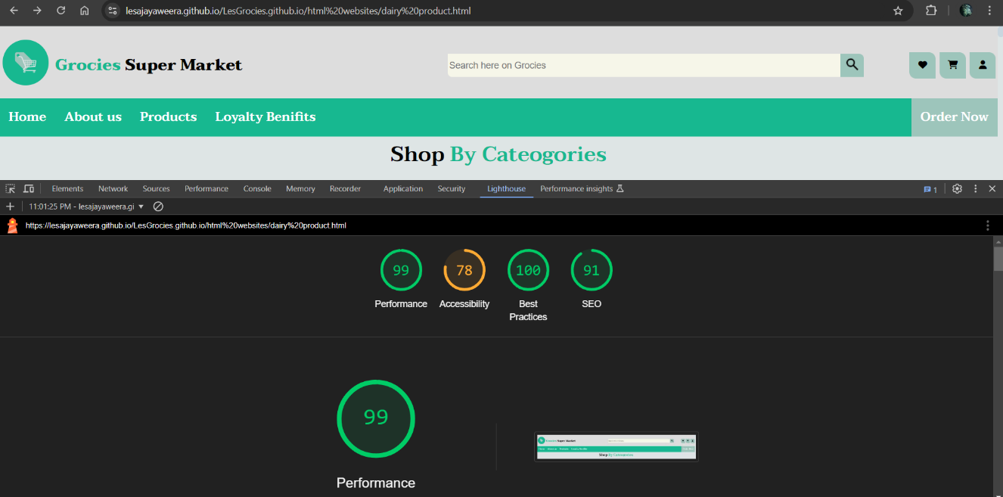

Figure 28 dairy desktop light house

Figure 29 dairy mobile lighthouse

Figure 30 fish desktop lighthouse

Figure 31 fish mobile lighthouse

Figure 32 fruits desktop lighthouse

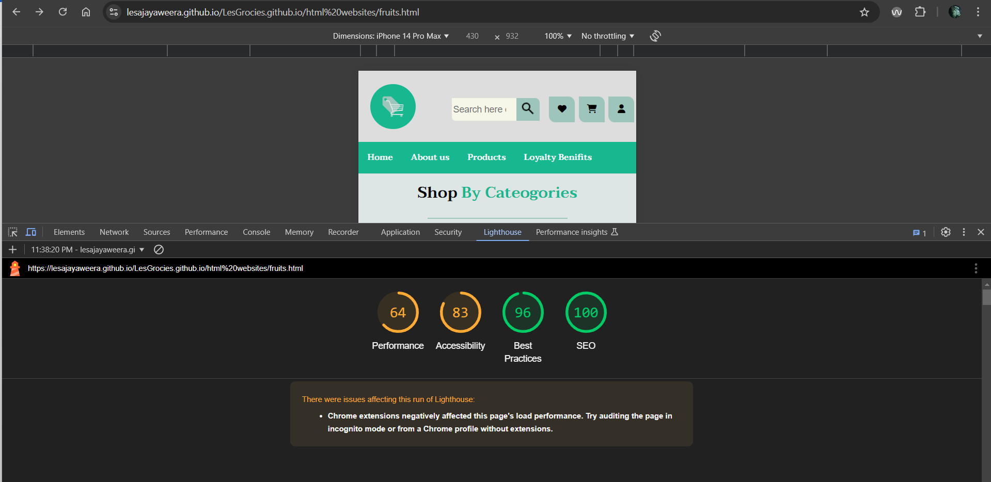

Figure 33 fruits mobile light house

Figure 34 loyalty desktop lighthouse

Figure 35 loyalty mobile lighthouse